Paper Title

First Author¹*, Second Author², Third Author³, Fourth Author⁴

¹Affiliation, Country
²Affiliation, Country
^{3,4}Affiliation, Country

*) Corresponding author: author@gmail.com

Abstract

The equations are an exception to the prescribed specifications of this template. You will need to determine whether or not your equation should be typed using either the Times New Roman or the Symbol font (please no other font). To create multileveled equations, it may be necessary to treat the equation as a graphic and insert it into the text after your paper is styled. Margins, column widths, line spacing, and type styles are built-in; examples of the type styles are provided throughout this document and are identified in italic type, within parentheses, following the example. Some components, such as multi-leveled equations, graphics, and tables are not prescribed, although the various table text styles are provided.

Keywords: word; word; word.

Introduction

This template, modified in MS Word 2007 and saved as a “Word 97-2003 Document” for the PC, provides authors with most of the formatting specifications needed for preparing electronic versions of their papers. All standard paper components have been specified for three reasons: (1) ease of use when formatting individual papers, (2) automatic compliance to electronic requirements that facilitate the concurrent or later production of electronic products, and (3) conformity of style throughout a conference proceedings.
Margins, column widths, line spacing, and type styles are built-in; examples of the type styles are provided throughout this document and are identified in italic type, within parentheses, following the example. Some components, such as multi-leveled equations, graphics, and tables are not prescribed, although the various table text styles are provided. The formatter will need to create these components, incorporating the applicable criteria that follow.
In this study, we discuss the factors which influence higher education students’ volunteering as well as their voluntary organization and group membership through linear and logistic regression models. In the post-socialist countries, civic engagement is underdeveloped, but recent years have seen a rise in volunteering and non-governmental organization memberships, which, however, still lag behind Western European countries. The same is true for higher education students’ civic engagement. Consequently, it is important to follow the above trends and to uncover the social and demographic background factors, which affect civic engagement. In the summary, we evaluate our hypotheses, which is followed by some recommendations for education policy

Literature Review (if any)

In the literature on higher education, civic engagement of students is discussed in connection with the development in academic and life skill competences, civic consciousness, and responsibility (Astin and Sax, 1998; Hesser, 1995; Eyler, Giles, and Braxton 1997; Mabry, 1998; Khasanzyanova, 2017), it is referred to as a special teaching method (Freese 1998, Zlokowski 1996, Mabry 1998) and as a protection against attrition (Kim & Schneider 2005; Perna & Titus 2005; Baker 2008; Altbach 2009; Pusztai 2015; Pusztai et al. 2019)
Method (for original research)

Setting and Participant

The database consists of a large-sample student survey1 (N=2,199), conducted in the academic year 2018/19. The survey was carried out at higher education institutions in Eastern Hungary2 and in four other countries3 (Slovakia, Romania, Ukraine, Serbia). The Hungarian subsample (N=1,034) was collected using quota

Data Collection

The database consists of a large-sample student survey1 (N=2,199), conducted in the academic year 2018/19. The survey was carried out at higher education institutions in Eastern Hungary2 and in four other countries3 (Slovakia, Romania, Ukraine, Serbia). The Hungarian subsample (N=1,034) was collected using quota

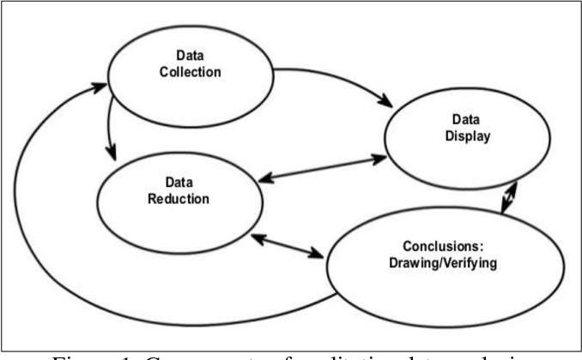
Figure 1. Interactive model of analysis

Result and Discussion

As of 2020, 137,094 migrant brides are married to Korean men, of which 86% are from China, Vietnam, and Japan. The highest number are women from China including those who are Korean-Chinese at 44% (60,324), followed by those from Vietnam at 32% (44,172) and Japan at 10% (14,184) (Monthly Report of Korea Immigration Service (April, 2020), Ministry of Justice). In this regard, how should the women from these countries, who constitute the majority of migrant brides in Korea, be educated on Korean history? Before developing a systematic approach to education, the degree of recognition of basic Korean history was investigated with a focus on general historical knowledge, religion and culture, and relations between the two countries.

Table 1. What is your preferred teaching method?
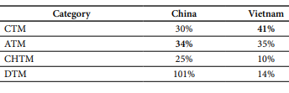
According to Table 1, the degree of recognition of Korean history as well as religion and culture by migrant brides from the three countries was not high and the rate of correct answers varied depending on their country of origin. Those from China and Japan tended to observe Korean history from the historical viewpoint of their own countries (Kim & Jeong, 2004; Yu, 2005), while those from Vietnam formed knowledge based on what they were taught, as the country is historically less involved than the other two countries

Conclusion

This study investigated the most effective method of teaching Korean history to migrant brides from China, Vietnam, and Japan. It was shown that before participating in the survey, the women from China and Japan preferred ATM, which aroused interest, and those from Vietnam preferred CTM. However, after a week of lectures, the Chinese and Japanese migrant brides preferred CHTM. The preference of the Vietnamese migrant brides for CHTM increased most by 20%.

Acknowledgment (if any)

This research was funded by…

References (APA Style)

Knowles, R. T. (2018). Teaching Who You Are: Connecting Teachers’ Civic Education Ideology to Instructional Strategies. Theory and Research in Social Education, 46(1), 68–109. https://doi.org/10.1080/00933104

